**Phase 8: Data Management & Deployment**

**Objective:**  
To ensure that all master and transactional data (Students, Companies, Internships) are accurately uploaded into Salesforce, making the system ready for live usage. This phase also includes the optional deployment of custom objects and automation if changes are developed in a Sandbox environment.

**Procedure**

**Step 1: Upload Master Data using Data Import Wizard**

1. **Prepare CSV Files**
   * Create separate CSV files for Students and Companies.
   * Include all required fields for each object (e.g., Name, Email, Roll Number, Department, Year, CGPA for Students; Name, HR Email, HR Phone, Industry for Companies).
   * Ensure field names match Salesforce API names.
2. **Launch Data Import Wizard**
   * Go to **Setup → Data → Data Import Wizard → Launch Wizard**.
3. **Select Object and Upload CSV**
   * For Students: select the **Student__c** object → Upload Students.csv.
   * For Companies: select the **Company__c** object → Upload Companies.csv.
4. **Map Fields**
   * Map each CSV column to the corresponding Salesforce field.
   * Ensure all required fields are correctly mapped.
5. **Start Import**
   * Click **Next → Start Import**.
   * After completion, review the import report to identify and correct any errors.  
       
     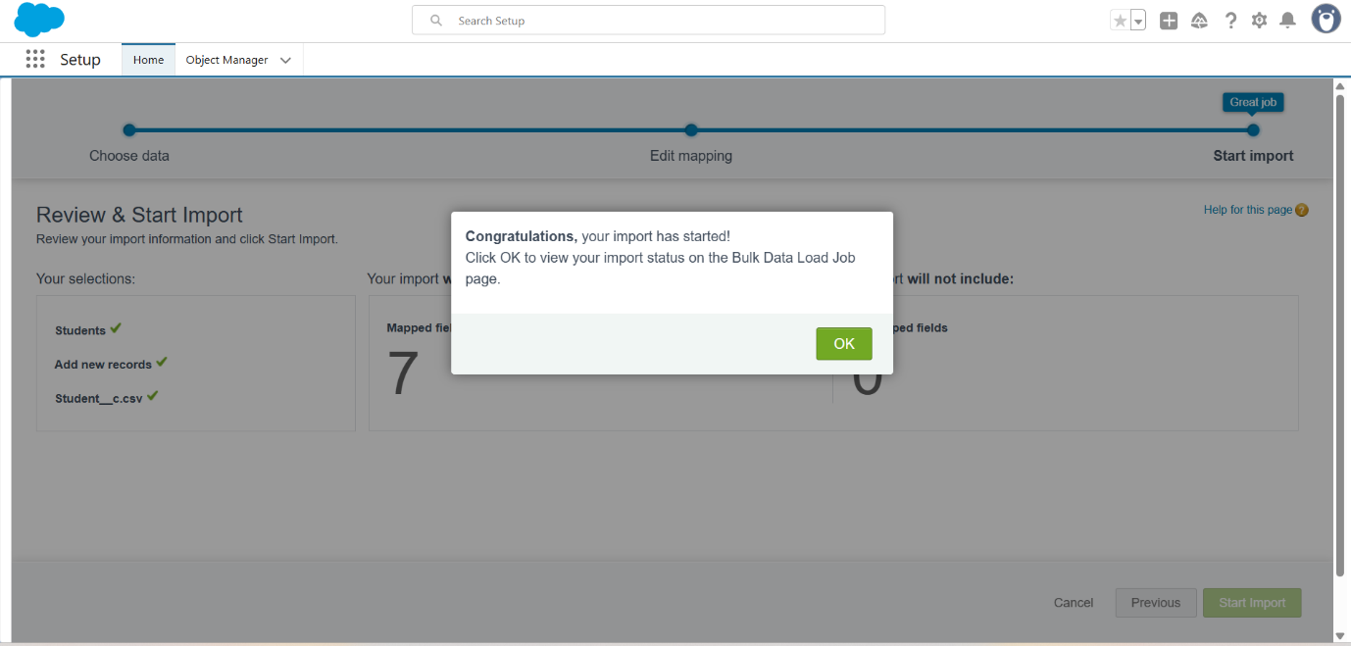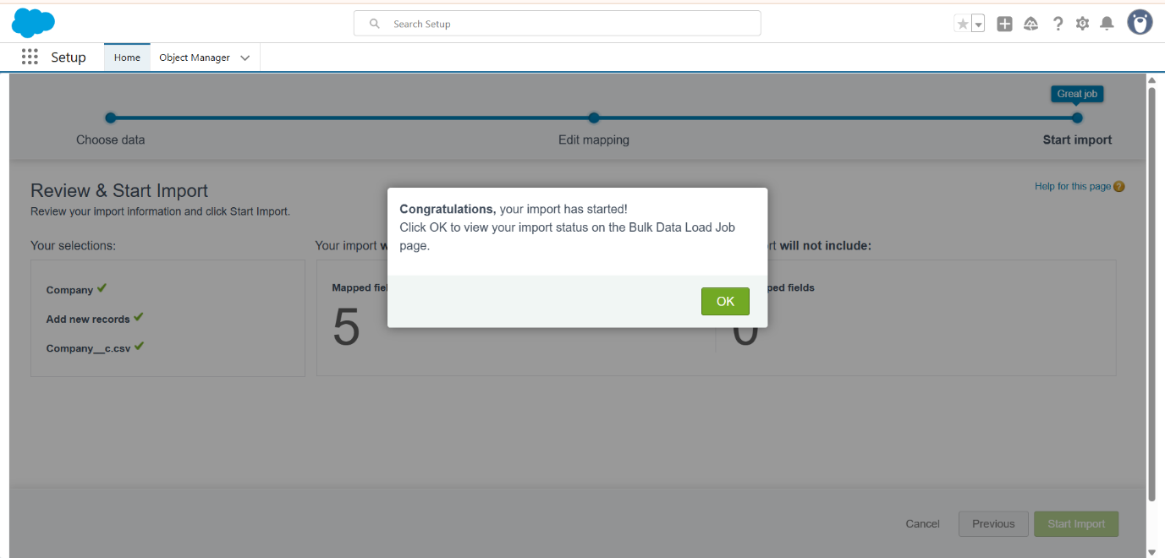

**Step 2: Upload Transactional Data using Data Loader / dataloader.io**

1. **Prepare CSV File**
   * Create Internships.csv including:
     + Internship Title (Name)
     + Company (Company__c – Salesforce Record ID or External ID)
     + Student (Student__c – optional, Salesforce Record ID or External ID)
     + Start Date (Start_Date__c)
     + End Date (End_Date__c)
     + Duration (Duration__c)
     + Stipend (Stipend__c)
     + Location (Location__c)
2. **Upload Data**
   * Using **dataloader.io** or Salesforce **Data Loader**:
     + Login with Salesforce credentials.
     + Select **Insert → Internship__c** object.
     + Upload CSV and map fields.
     + Run the task and download success/error reports.
3. **Verify Upload**
   * Confirm that all records have been successfully inserted.
   * Correct and re-upload any failed records if necessary.  
       
     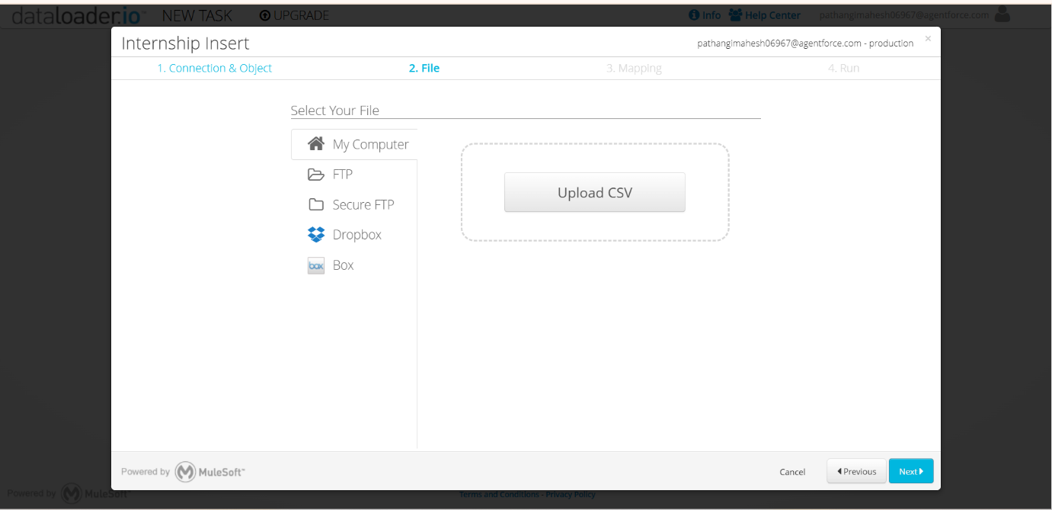

**Deliverables**

1. **Master Data Loaded**
   * Student records successfully uploaded.
   * Company records successfully uploaded.
2. **Transactional Data Loaded**
   * Internship records successfully uploaded, linked to Companies (and optionally Students).

**Conclusion:**  
Phase 8 ensures that the Salesforce org is fully populated with necessary master and transactional data, making it ready for testing or live usage. Using Data Import Wizard and Data Loader/dataloader.io provides a safe and accurate method for bulk data insertion without the need to manually enter each record.